SCB ODC activity

New activity has created in PMS for SCB ODC. After login in PMS, select PTPU activity from organization tree.

Menu ODC data Files having below three submenus:-
- Import Client Files
- Case Entry
- Export

Step 1: Import Client Files

Upload of output file (Excel) from ODC software

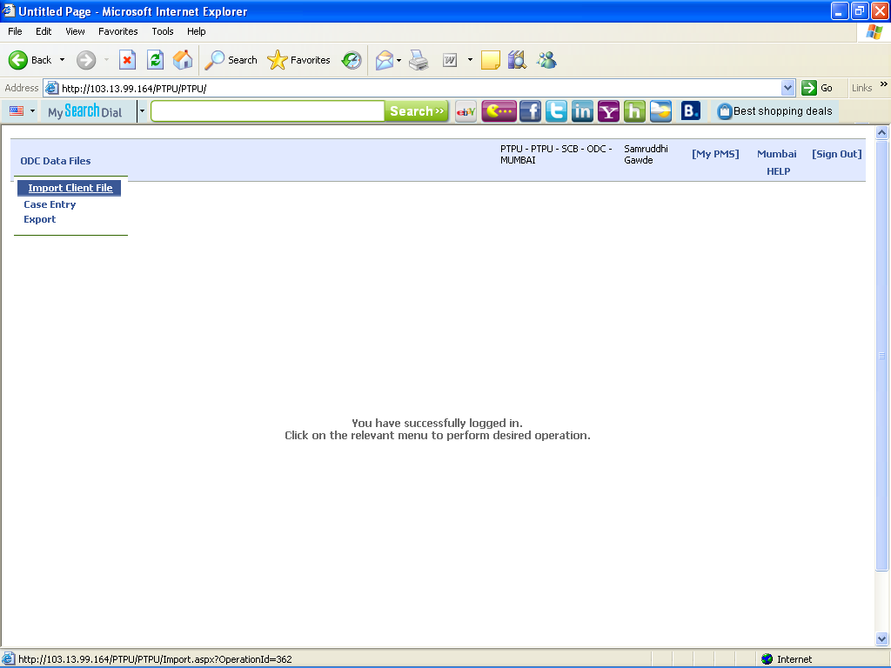

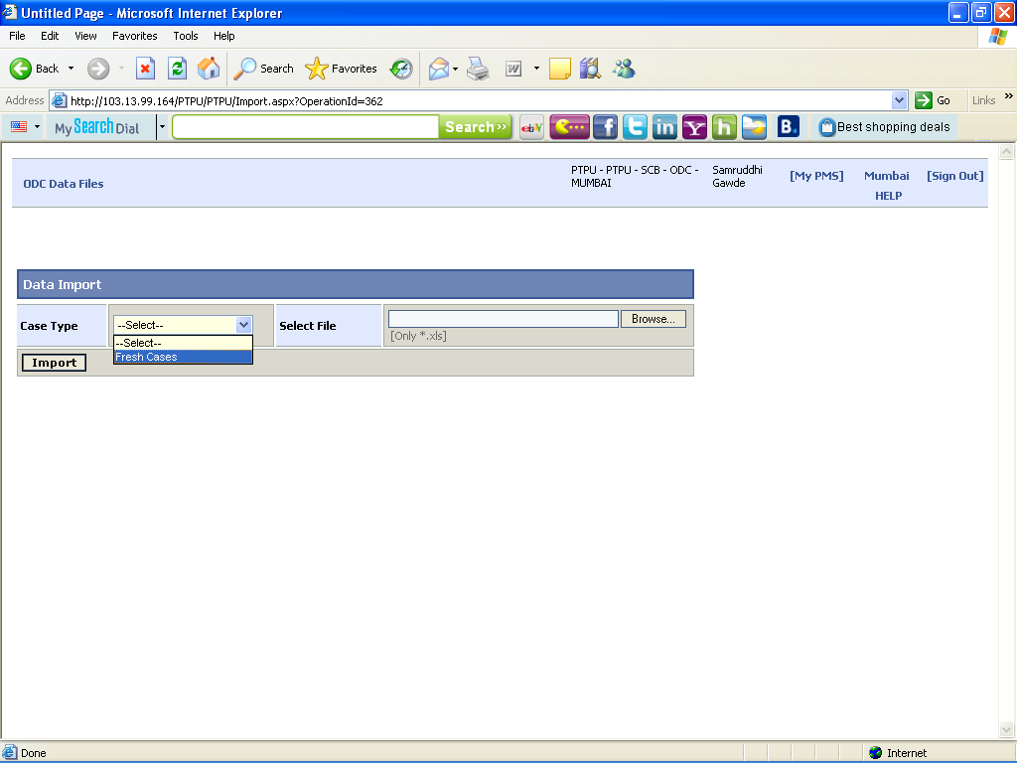

Step 2: Data Case Entry Form

Validation of data Capture in Utility for the Batch ID, Card No, Cheque No, Amount
Fields against the Output Data of ODC (Excel) uploaded.

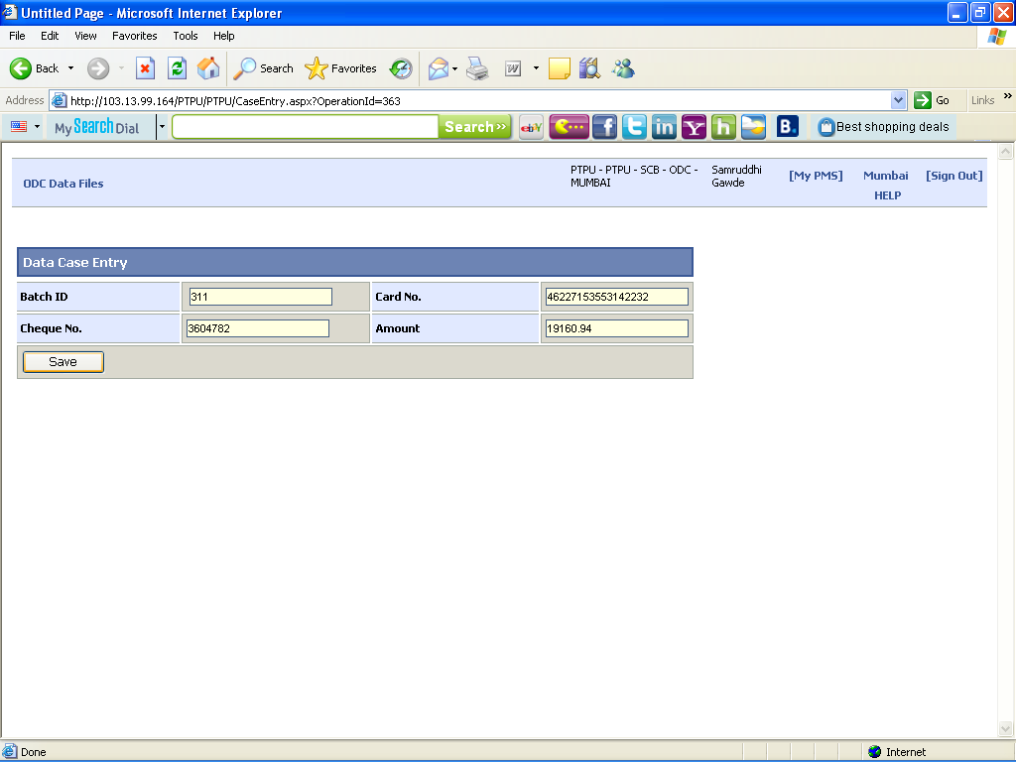

Step 3: Export

Throw the report with discrepancies found mismatches the data with each other

